1.SALESFORCE PLATFORM BASICS

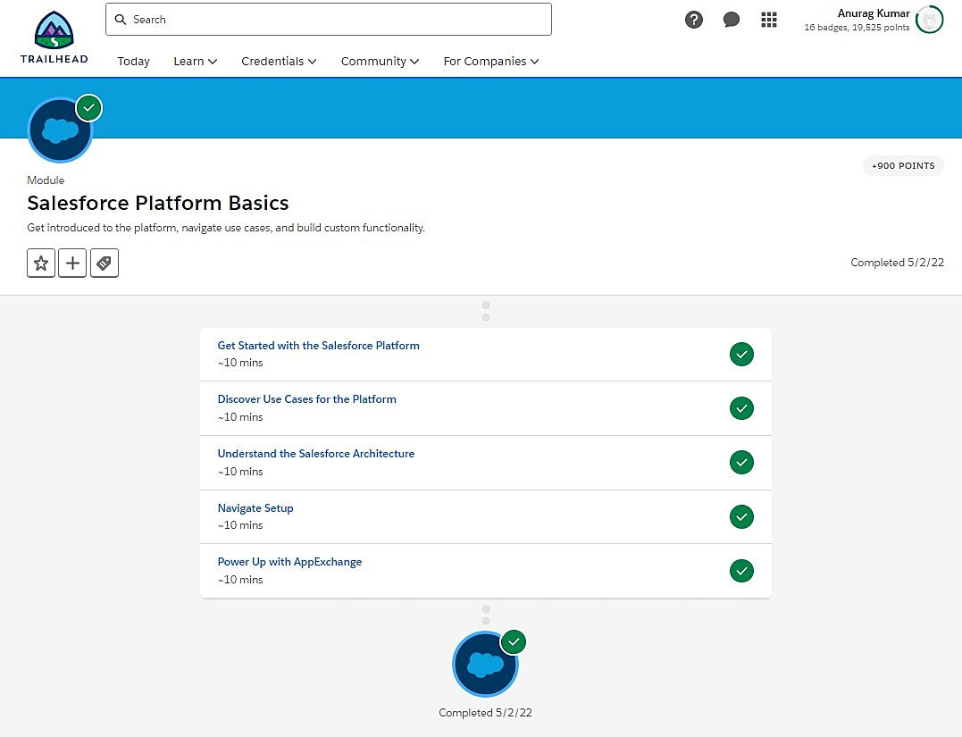

2.DATA MODELLING.

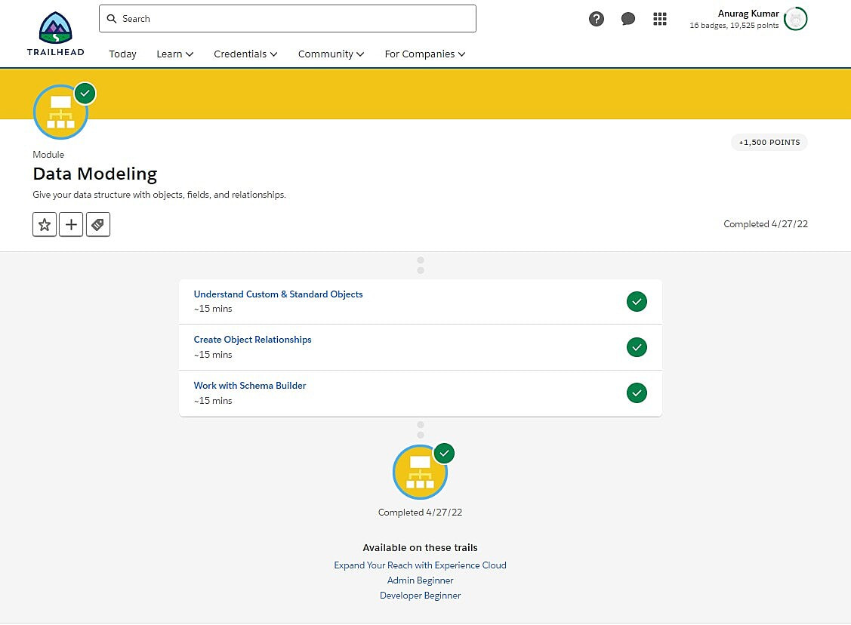

3. SALES CLOUD.

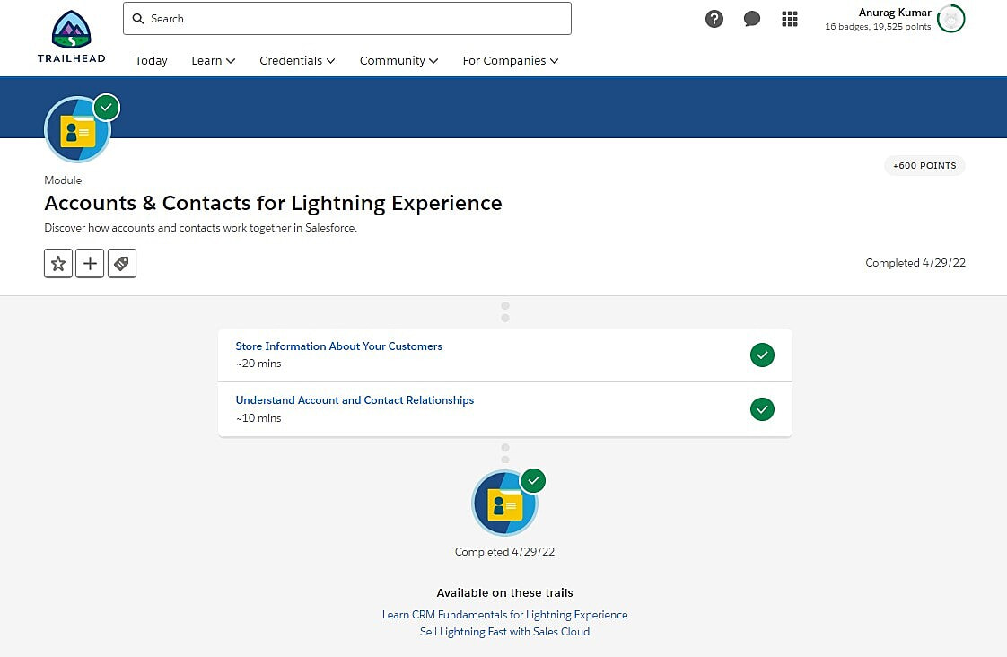

4. SERVICE CLOUD.

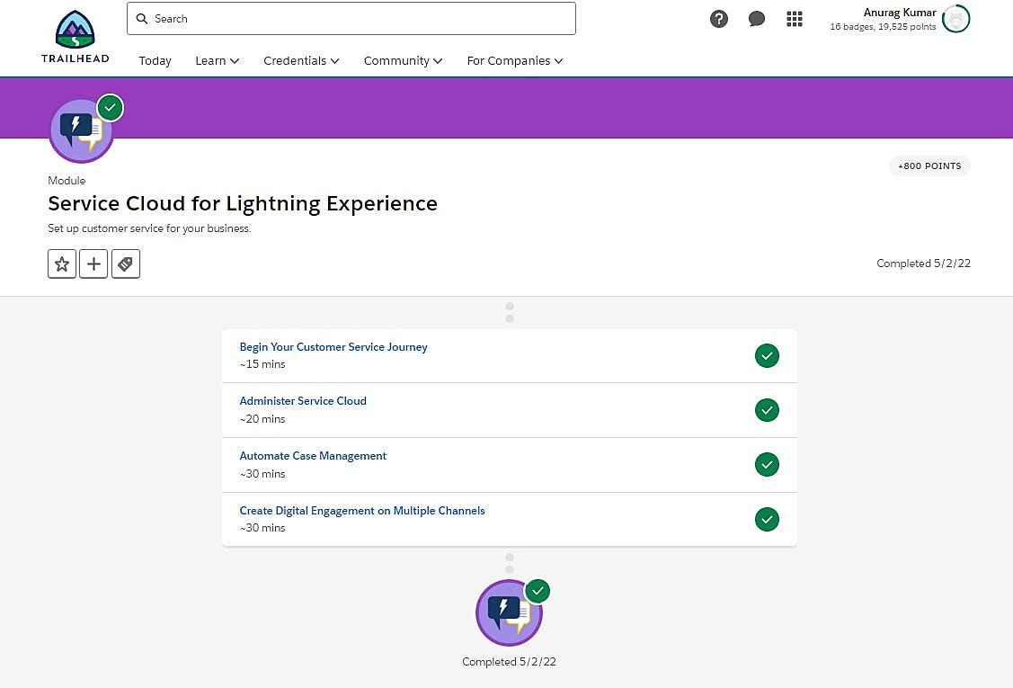

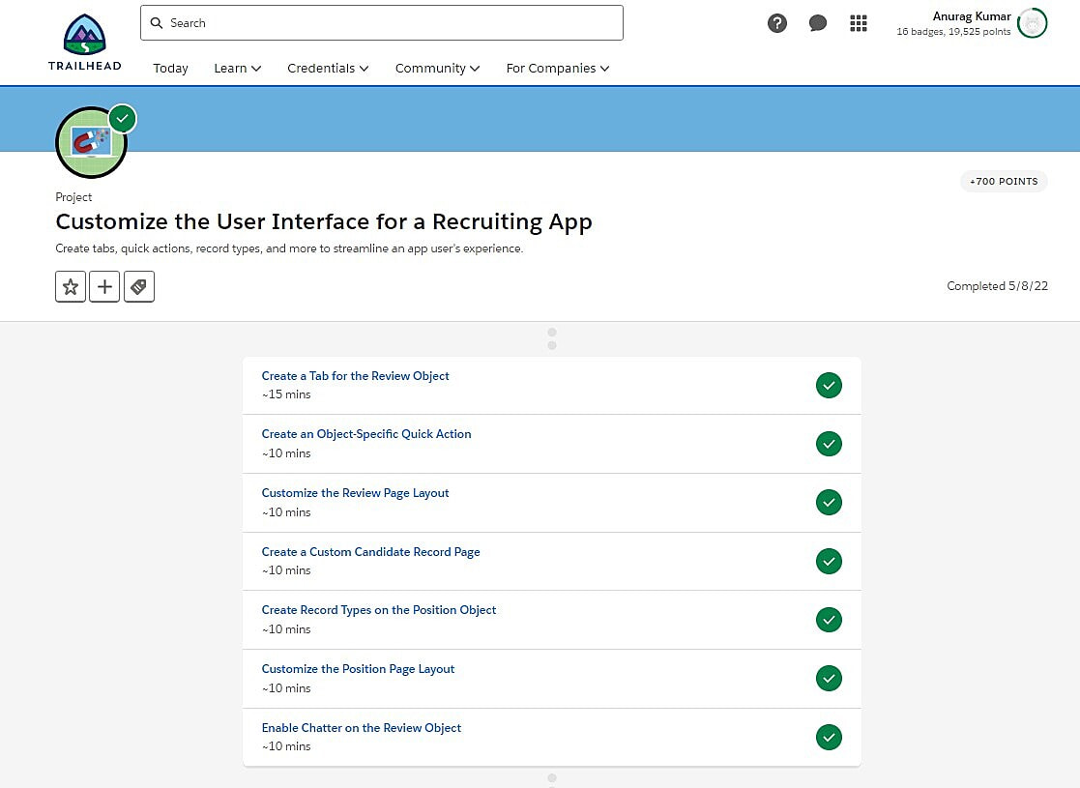

5. PROCESS AUTOMATION.

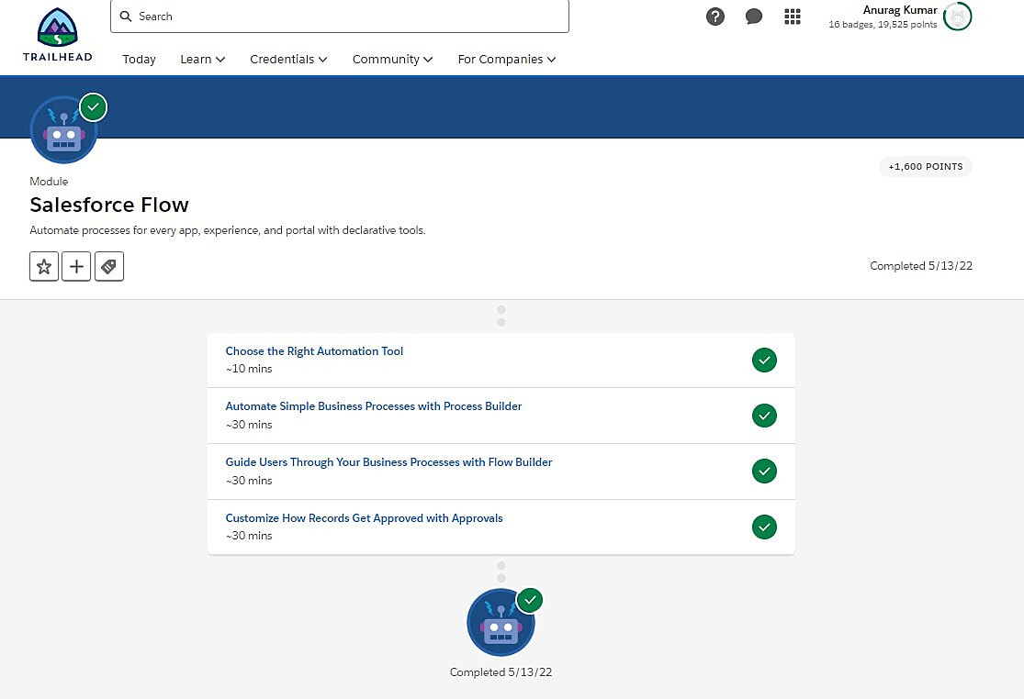

6. FLOW BASICS

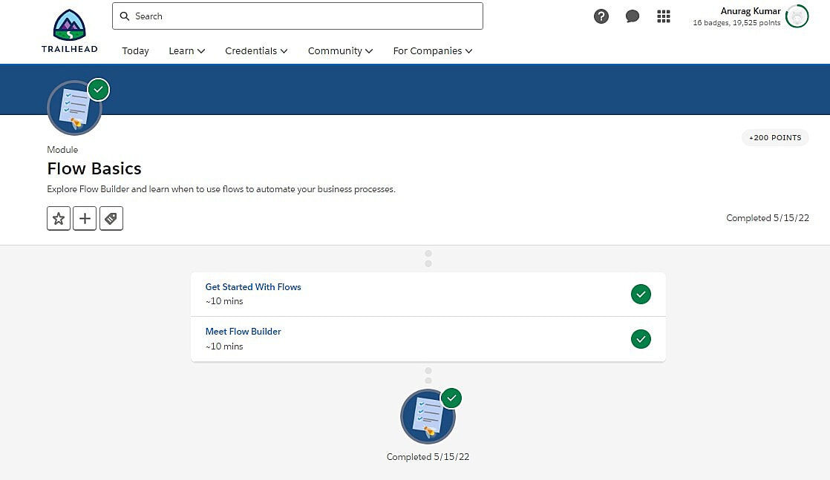

7. FLOW BUILDER.

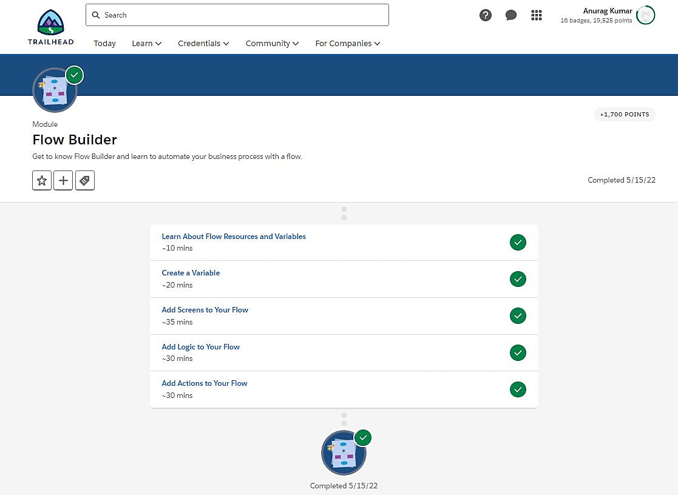

8. CHATTER ADMINISTRATION FOR LIGHTNING EXPERIENCE.

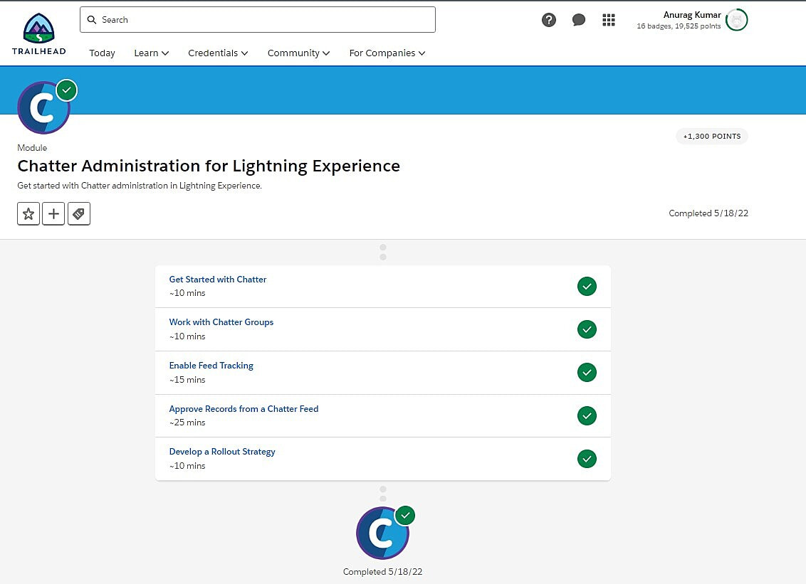

9. DATA SECURITY

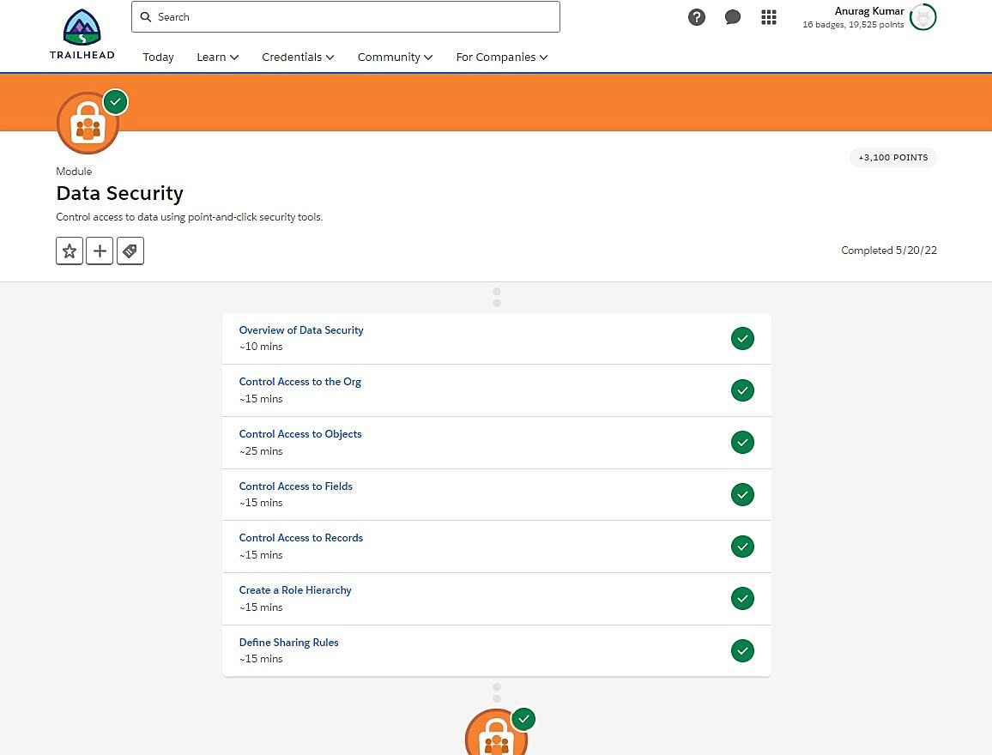

10. REPORTS & DASHBOARDS FOR LIGHTNING EXPERIENCE.

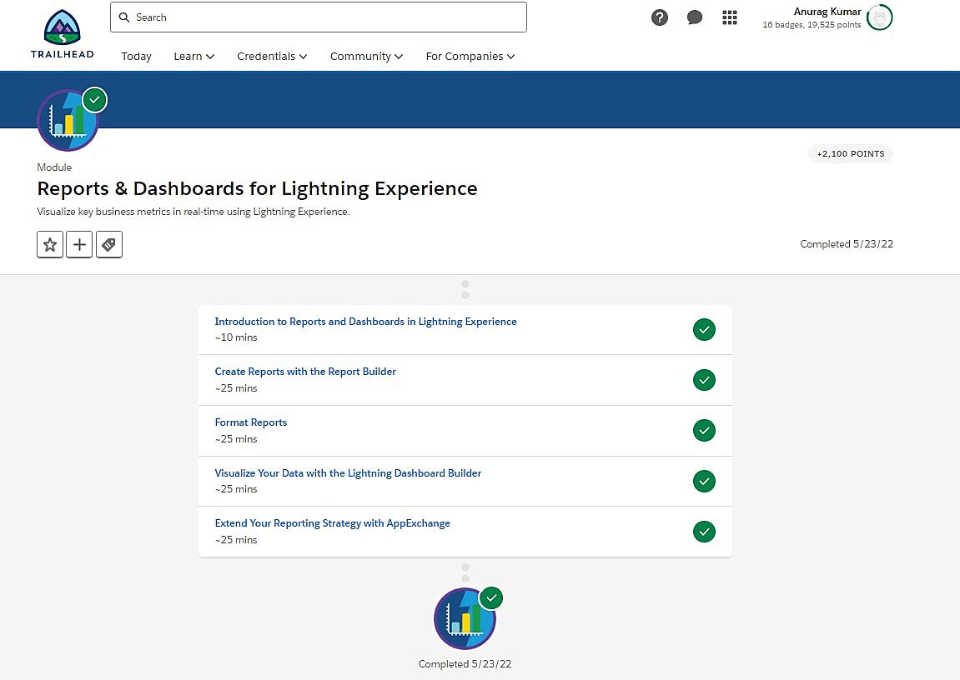

11. DATA MANAGEMENT

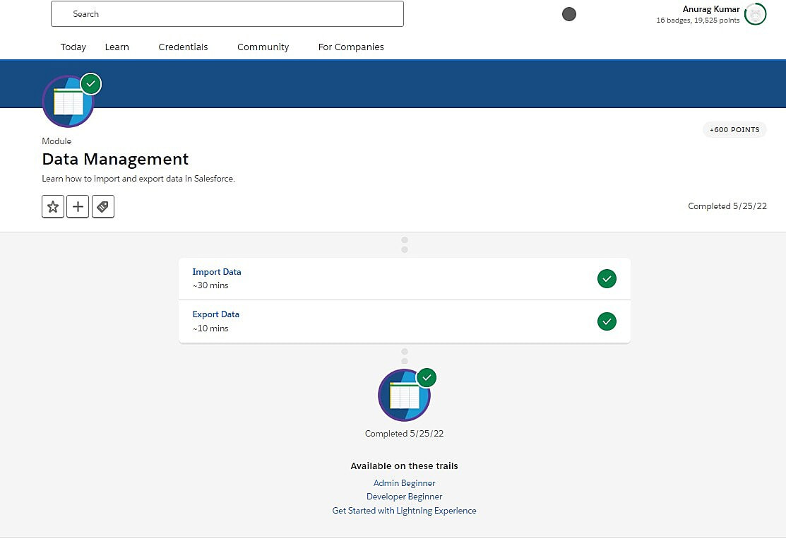

12. LIGHTNING EXPERIENCE CUSTOMIZATION.

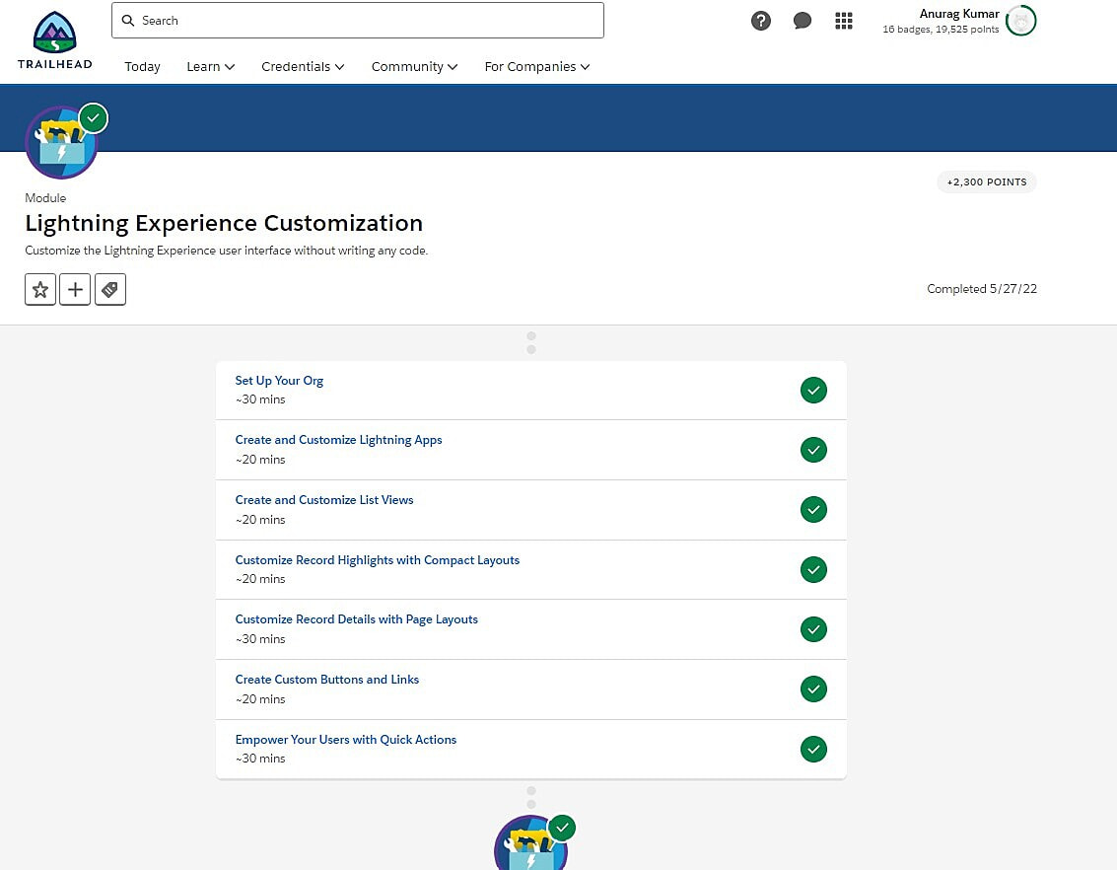

13. SALESFORCE MOBILE APP CUSTOMIZATION.

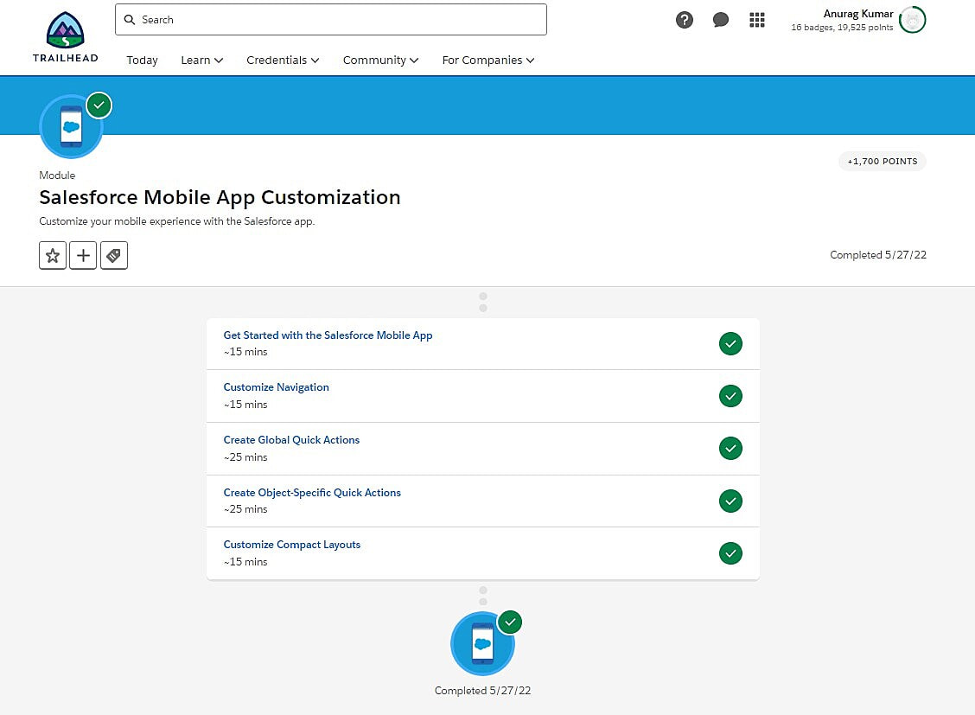

14. USER ENGAGEMENT.

